CSA1503-CLOUD COMPUTING AND BIG DATA ANALYTICS
Experiment-13

Create a Virtual Machine with 1 CPU, 2GB RAM and 15GB storage disk using a Type 2 Virtualization Software.
AIM
To create and configure a Virtual Machine using VMware Workstation (Type 2 Hypervisor) with 1 CPU, 2 GB RAM, and a 15 GB virtual hard disk.
PROCEDURE
Step 1
Open VMware Workstation.
Step 2
Click Create a New Virtual Machine.
Step 3
Select Typical (Recommended) and click Next.
Step 4
Choose the Ubuntu ISO file (or select I will install the operating system later).
Step 5
Select the Guest Operating System as Linux → Ubuntu 64-bit.
Step 6
Enter the Virtual Machine name and choose the storage location.
Step 7
Set the virtual hard disk size to 15 GB.
Step 8
Click Customize Hardware and configure:
- Processor: 1
- Memory: 2 GB (2048 MB)
Step 9
Click Finish to create the Virtual Machine.
Step 10
Power on the Virtual Machine and install Ubuntu.

IMPLEMENTATION:
STEP 1: Open VMware Workstation.
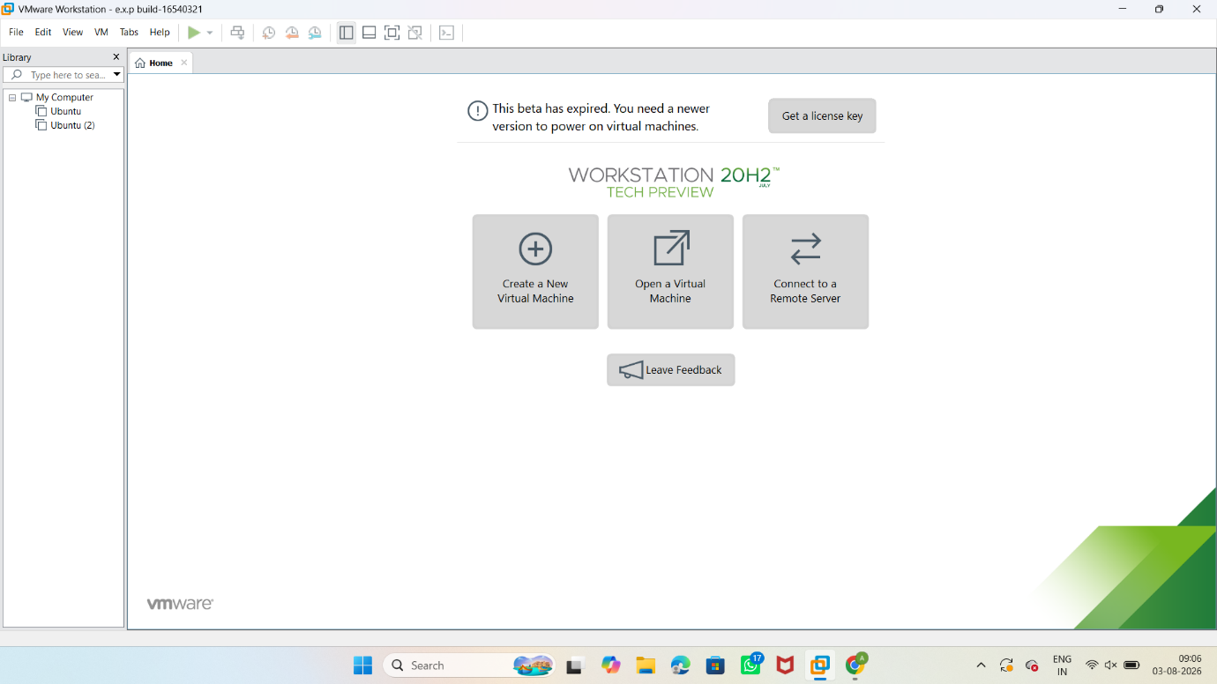
STEP 2: Set the virtual hard disk size to 15 GB.

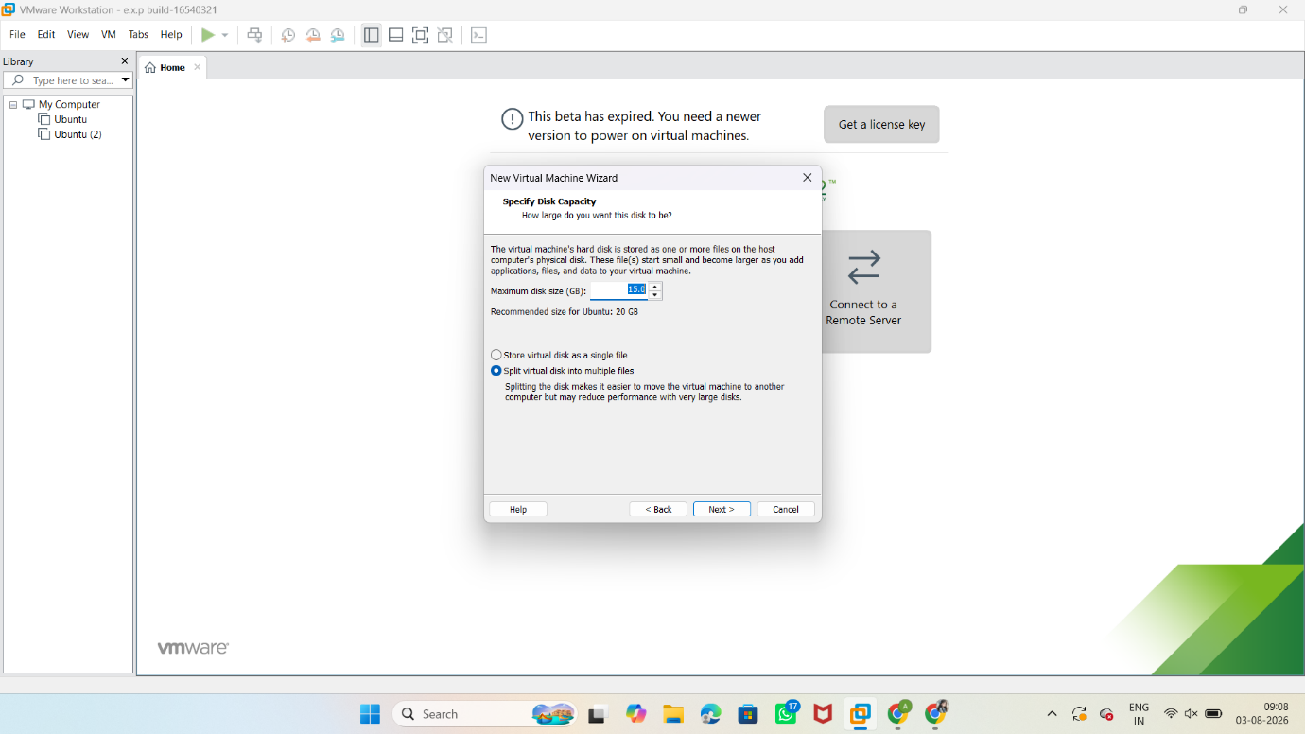

STEP 3: SET THE MEMORY SIZE 2 GB
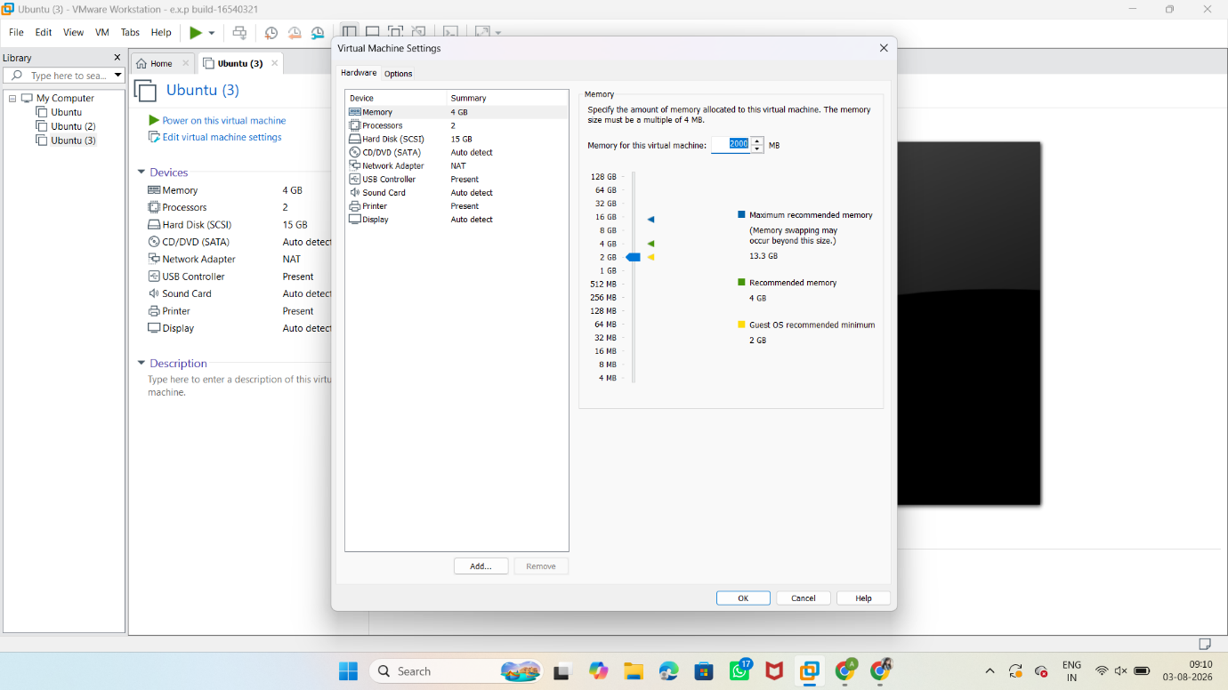

STEP 4: Click Customize Hardware and configure:
- Processor: 1

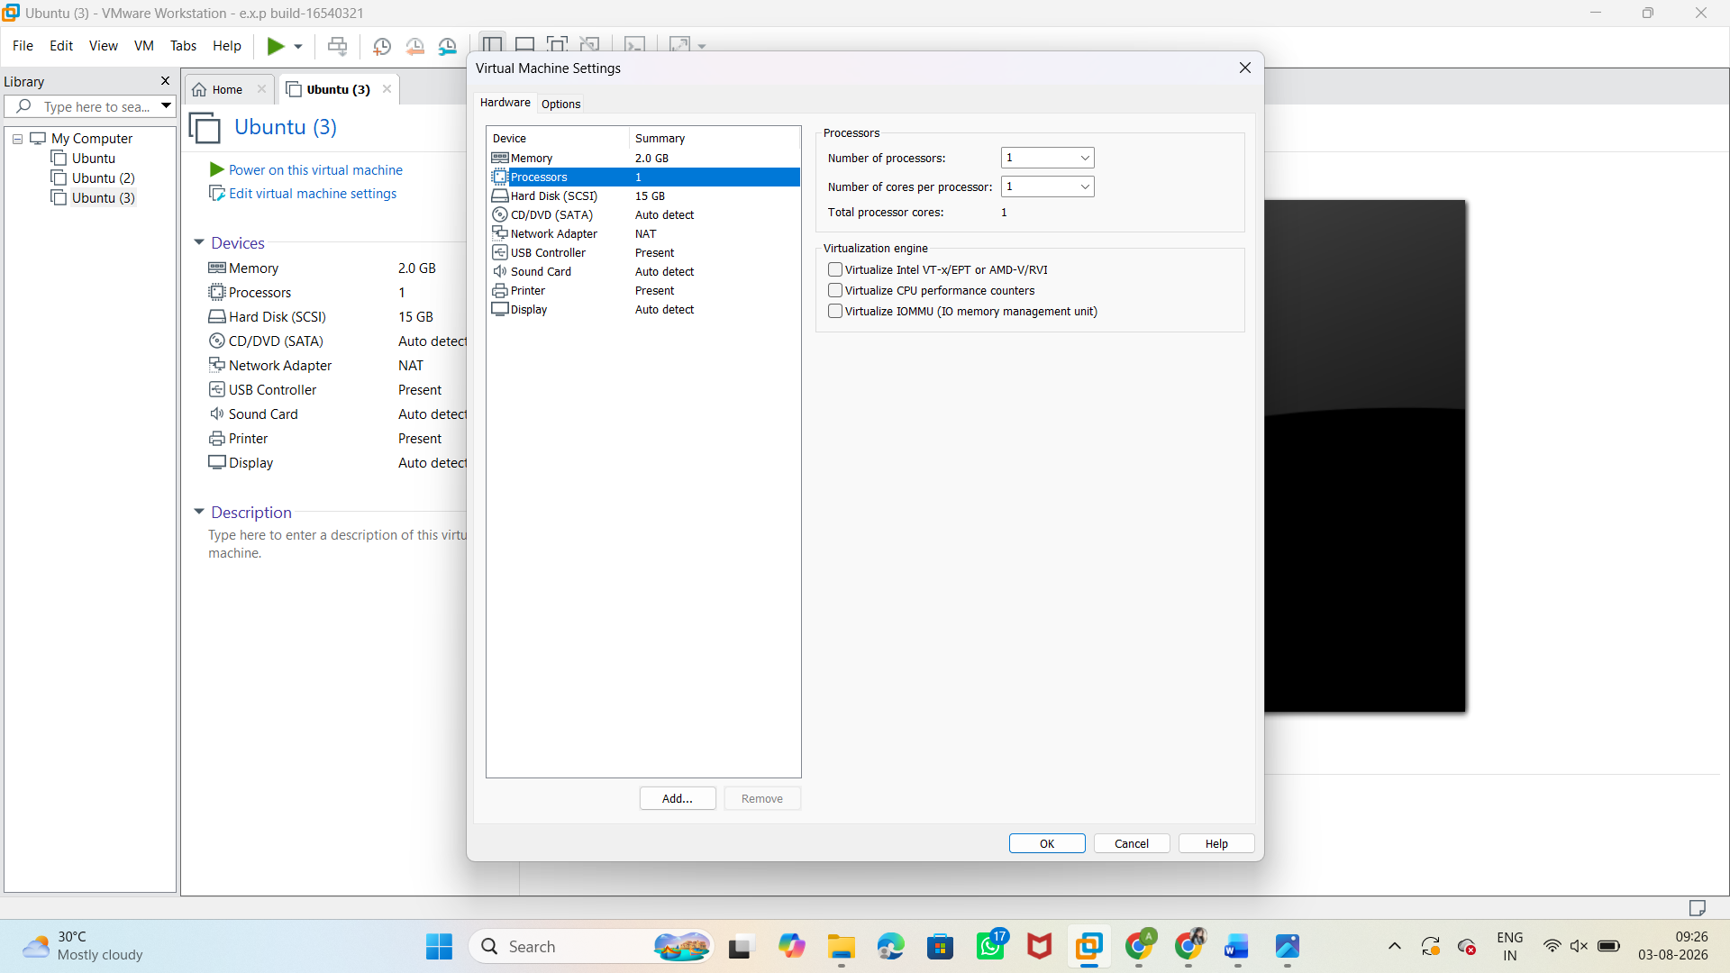

OUTPUT:

